CSE 581

**Lab 15: Triggers**

*Do this against YOUR own database.*

***For the entire lab, provide all of your SQL as text, inserted at the beginning of the document.***

***For each step also provide a screenshot of execution, showing the SQL and the results.***

***Please make sure both the SQL and the screenshots are marked w/ the question number that they are answering.***

**Steps:**

1. Create a trigger[1] on insert/delete/update of the Enrollment table:
   1. when inserting a new record, update the Courses table’s OpenSeats for the course into which the student is being enrolled.
   2. when deleting a record, update the Courses table’s OpenSeats for the course from which the student was deleted.
   3. if an update happened on the CourseId (student switched courses), adjust the Courses table’s OpenSeats accordingly.

CREATE TRIGGER Lab15_Triggers

ON CourseEnrollment

AFTER INSERT, DELETE, UPDATE AS

IF (EXISTS (SELECT * FROM INSERTED)) AND (NOT EXISTS (SELECT * FROM DELETED))

IF UPDATE (CourseId)

begin

Declare @InsertCourseId INT

select @InsertCourseId = (select CourseId from inserted)

update courses

set OpenSeats = OpenSeats - 1 where CourseId = @InsertCourseId

end

IF (NOT EXISTS (SELECT * FROM INSERTED)) AND (EXISTS (SELECT * FROM DELETED))

begin

Declare @DeleteCourseId INT

select @DeleteCourseId = (select CourseId from deleted)

update courses

set OpenSeats = OpenSeats + 1 where CourseId = @DeleteCourseId

end

IF (UPDATE(CourseId))

BEGIN

IF (EXISTS (SELECT * FROM INSERTED)) AND (EXISTS (SELECT * FROM DELETED))

BEGIN

SELECT @InsertCourseId = (SELECT CourseId FROM INSERTED)

SELECT @DeleteCourseId = (SELECT CourseId FROM DELETED)

UPDATE Courses

SET OpenSeats = (OpenSeats - 1) WHERE CourseId = @InsertCourseId

UPDATE Courses

SET OpenSeats = (OpenSeats + 1) WHERE CourseId = @DeleteCourseId

END

END;

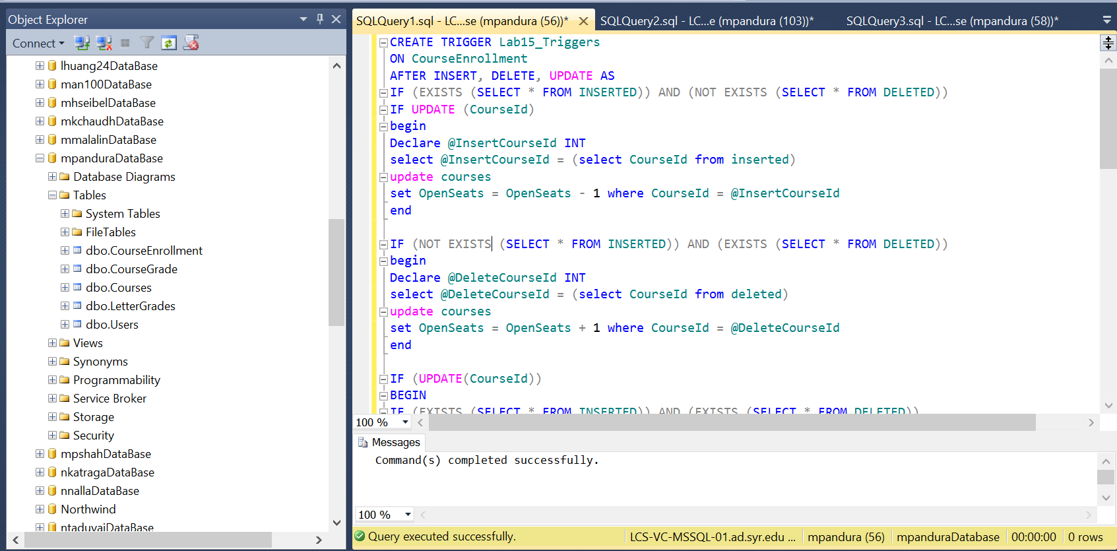

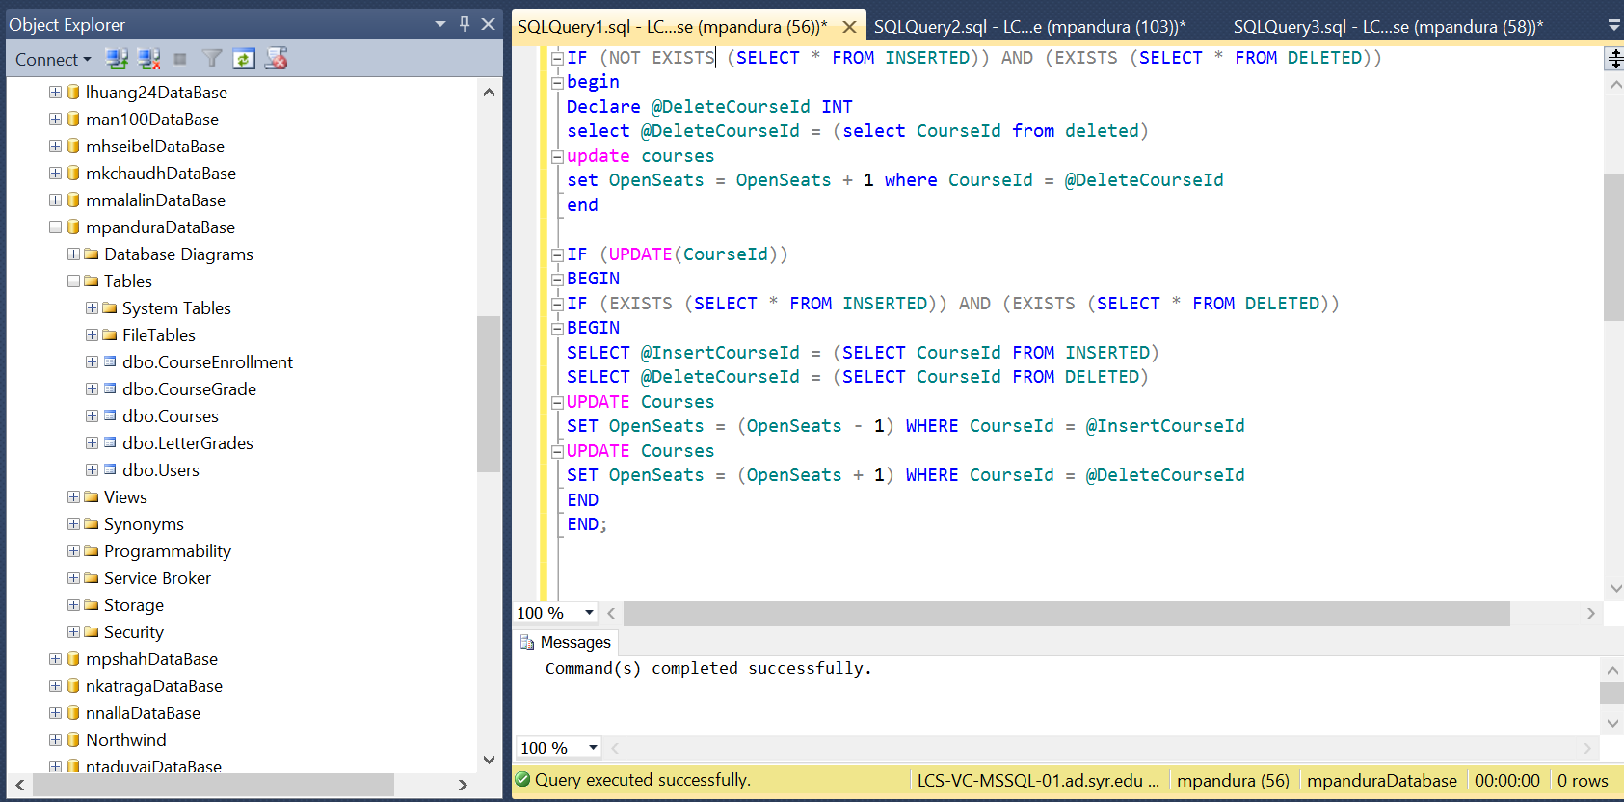

Initial Course and course enrollment tables

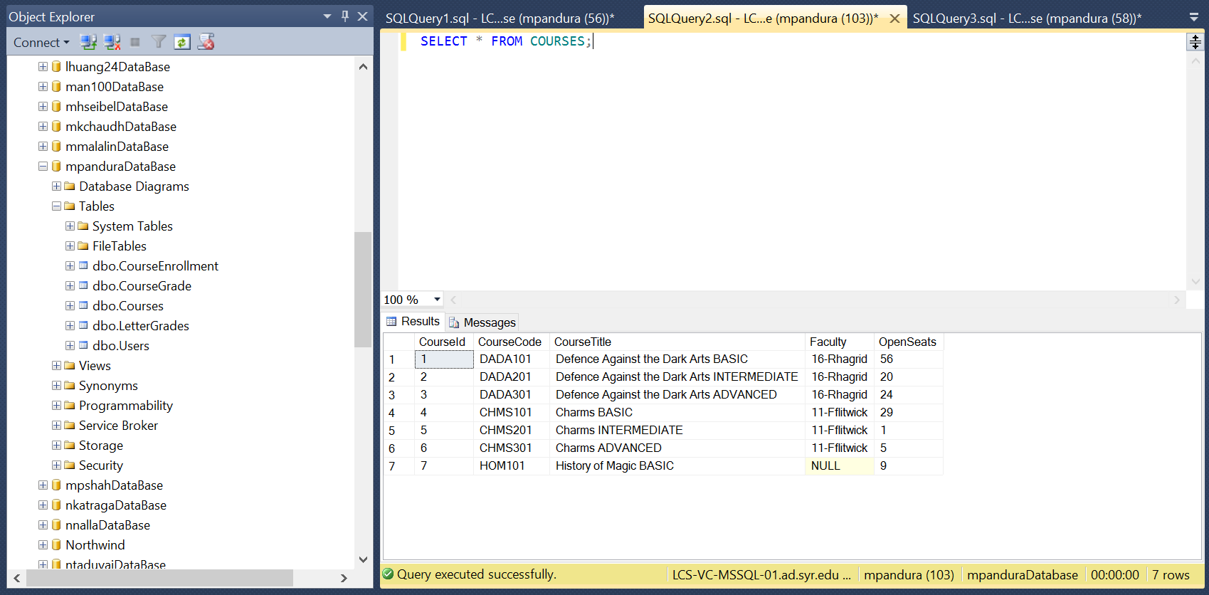

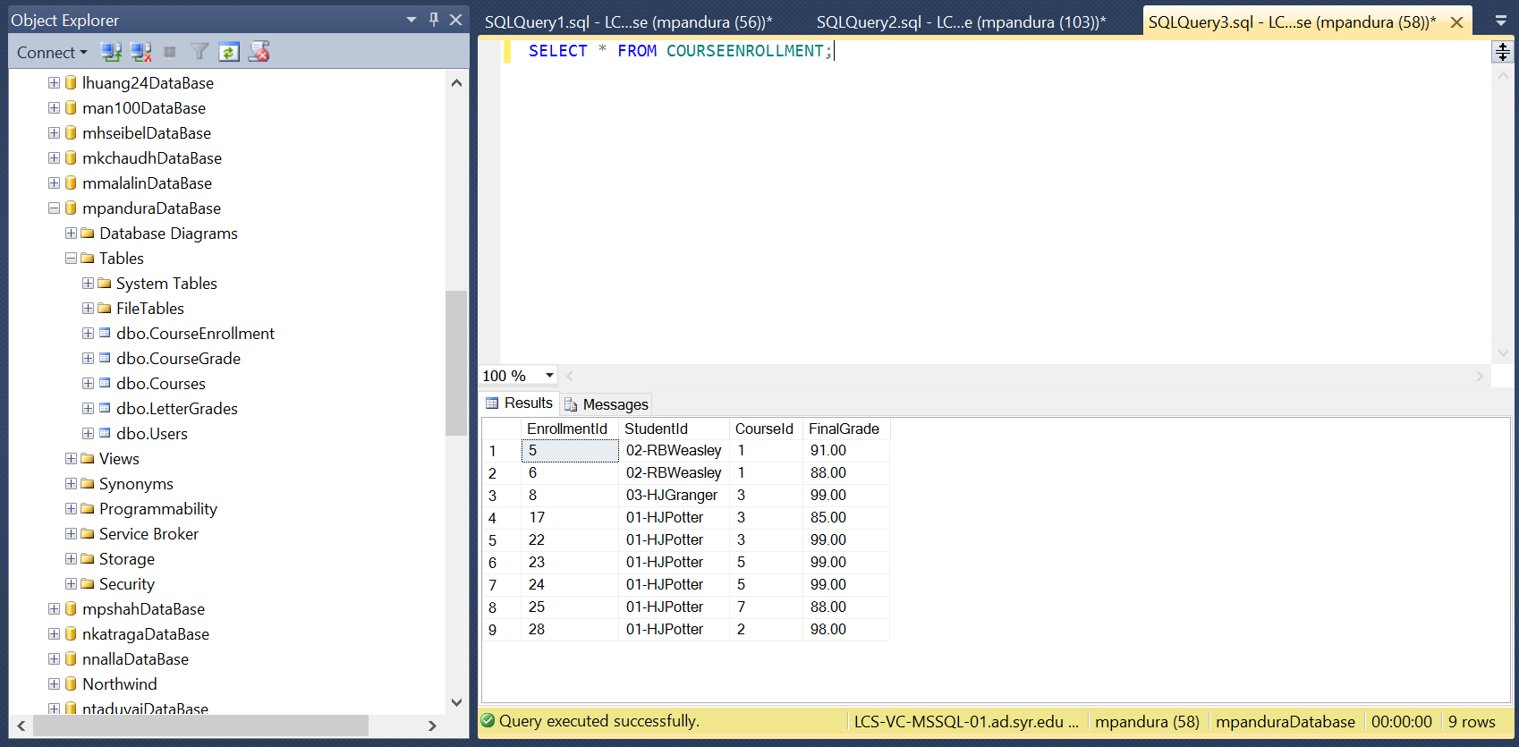

1. Insert, Delete and Update (course switch) the Enrollment table. Verify that everything worked as expected.



Insert:

INSERT INTO CourseEnrollment VALUES ('02-RBWeasley', 4, 85);

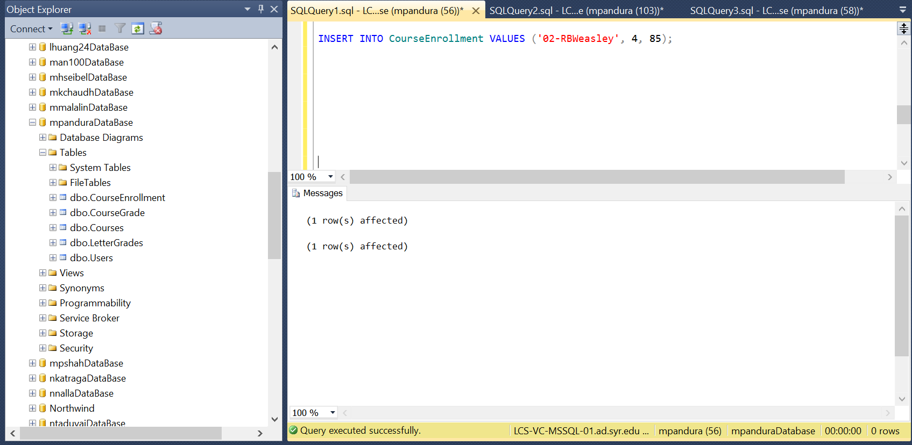

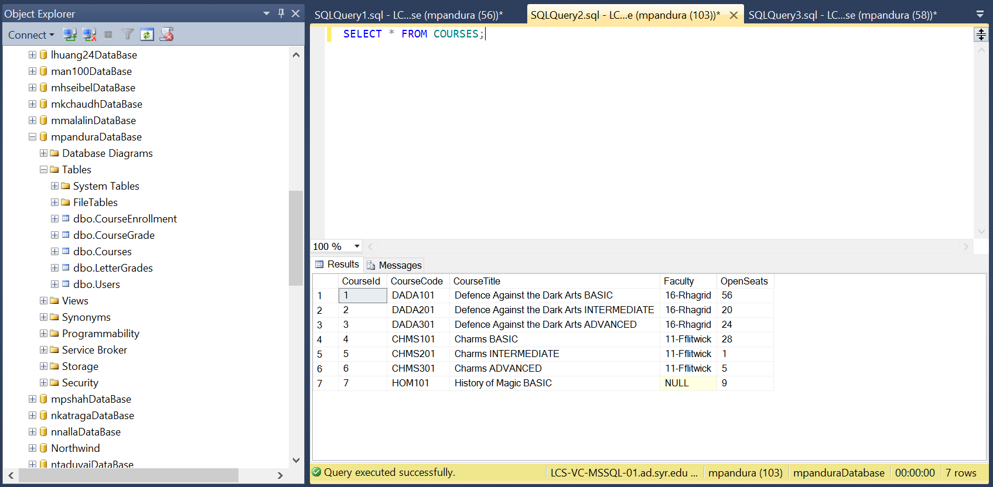



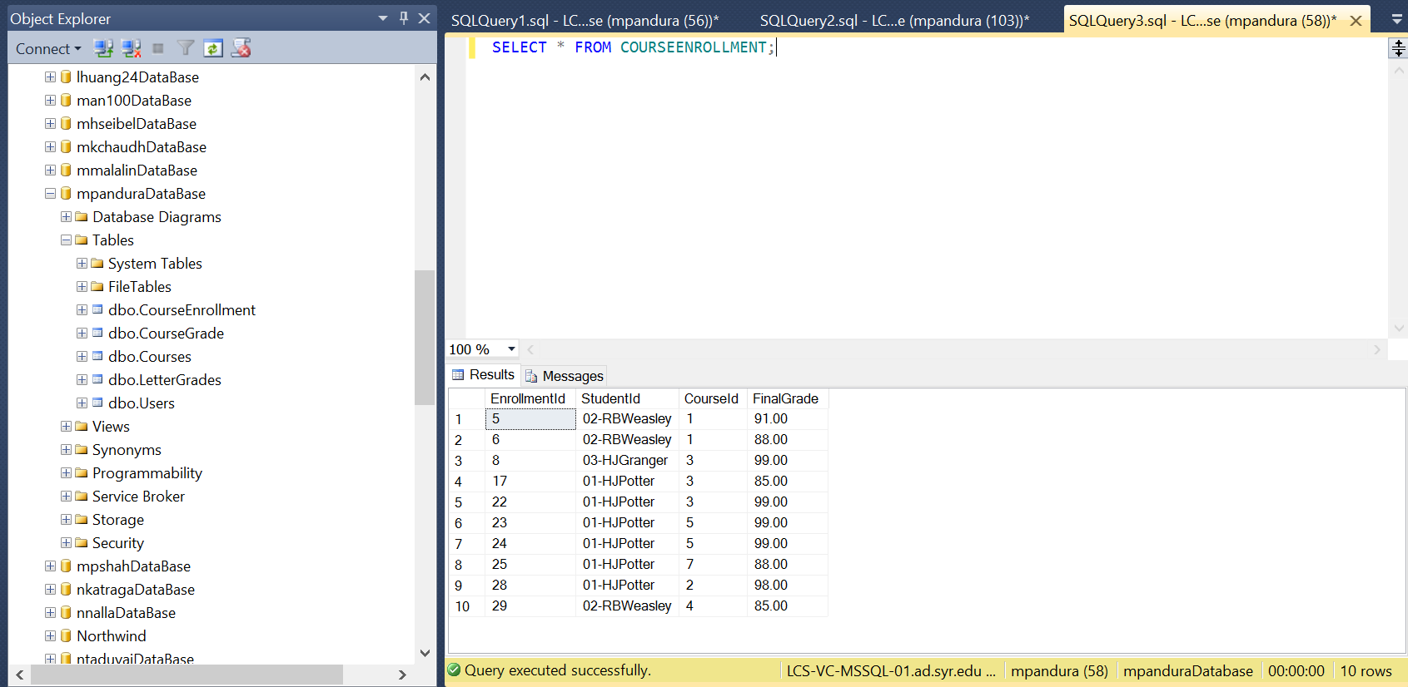



Delete:

DELETE FROM CourseEnrollment

WHERE EnrollmentId = 24;

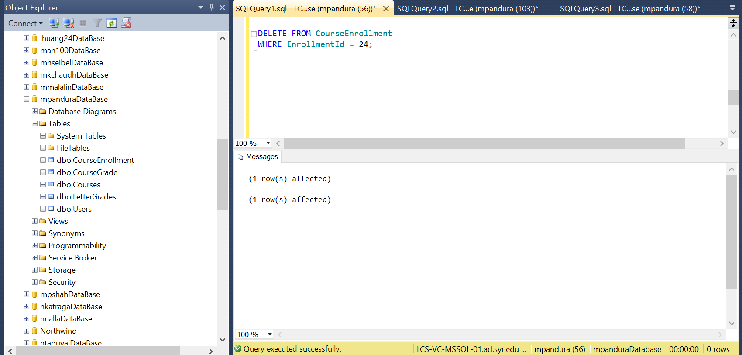

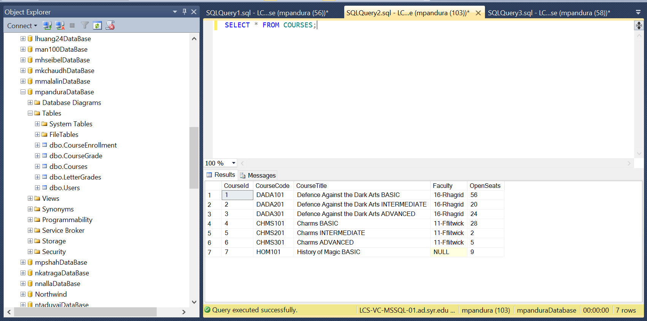



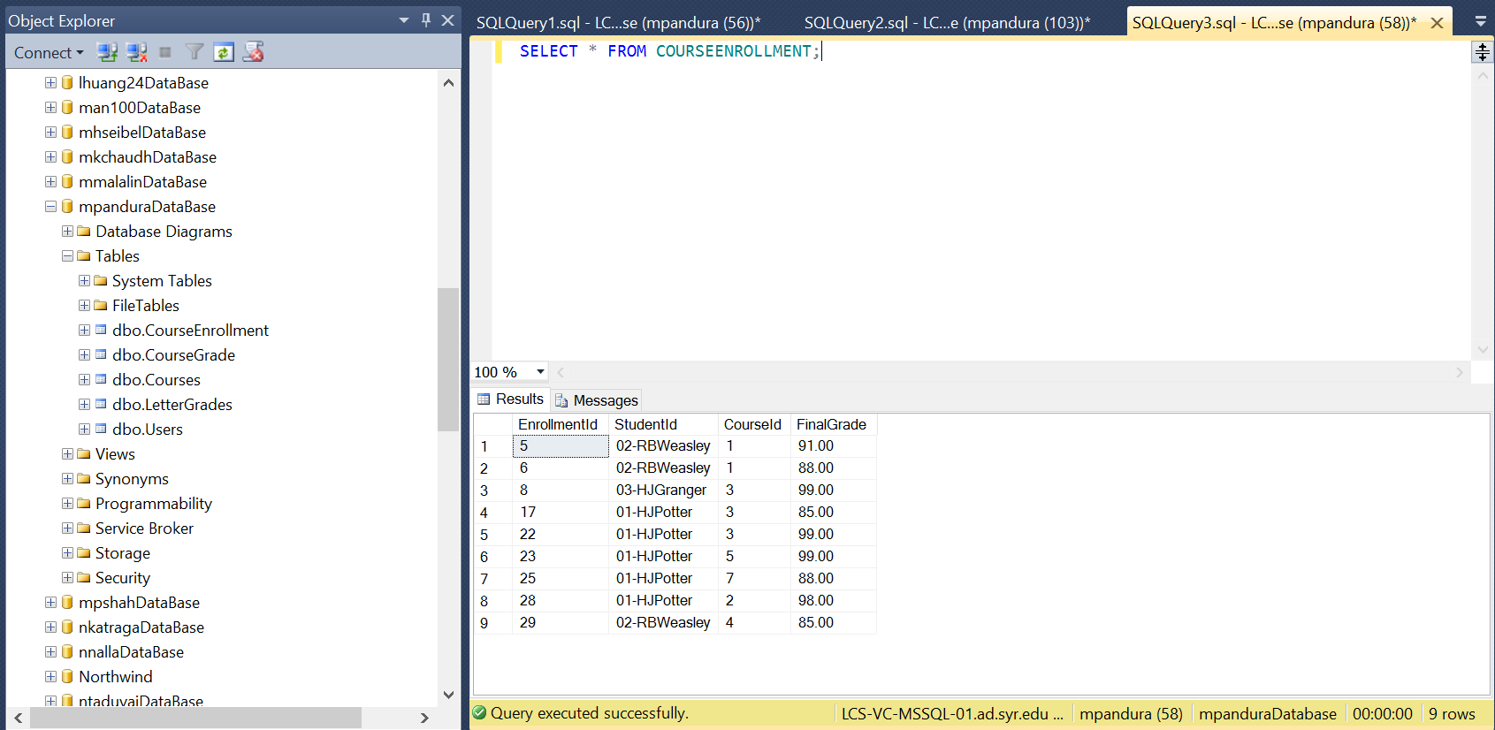

Update:

UPDATE CourseEnrollment

SET CourseId = 5 WHERE StudentId = '01-HJPotter' AND CourseId = 7;

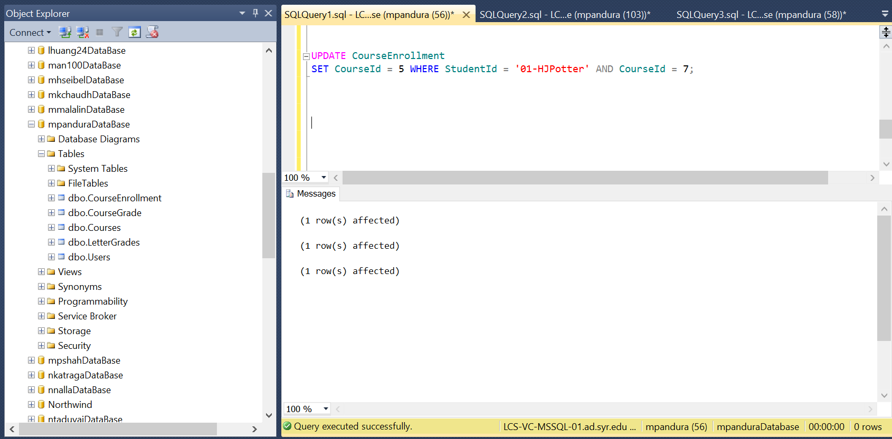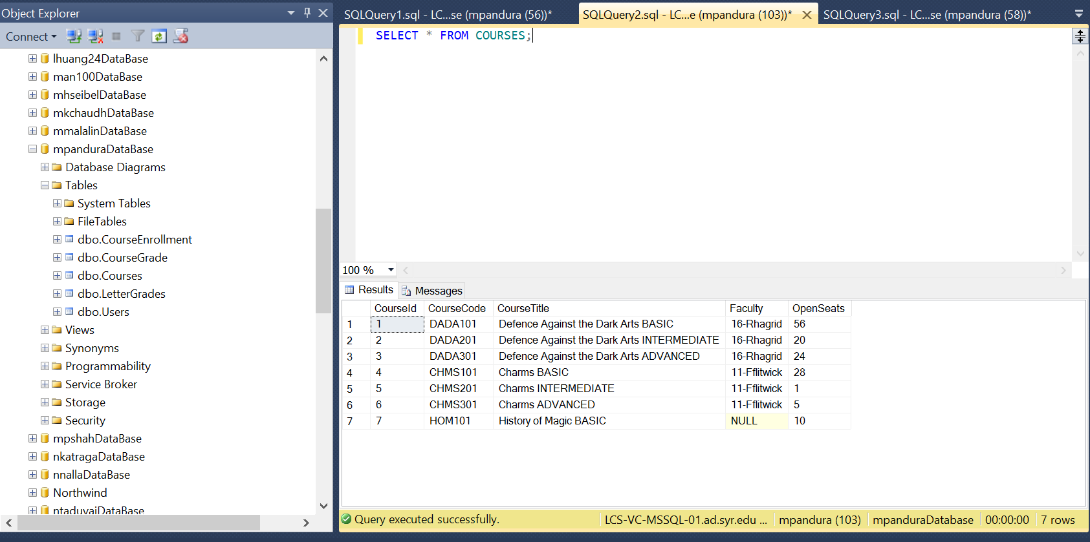



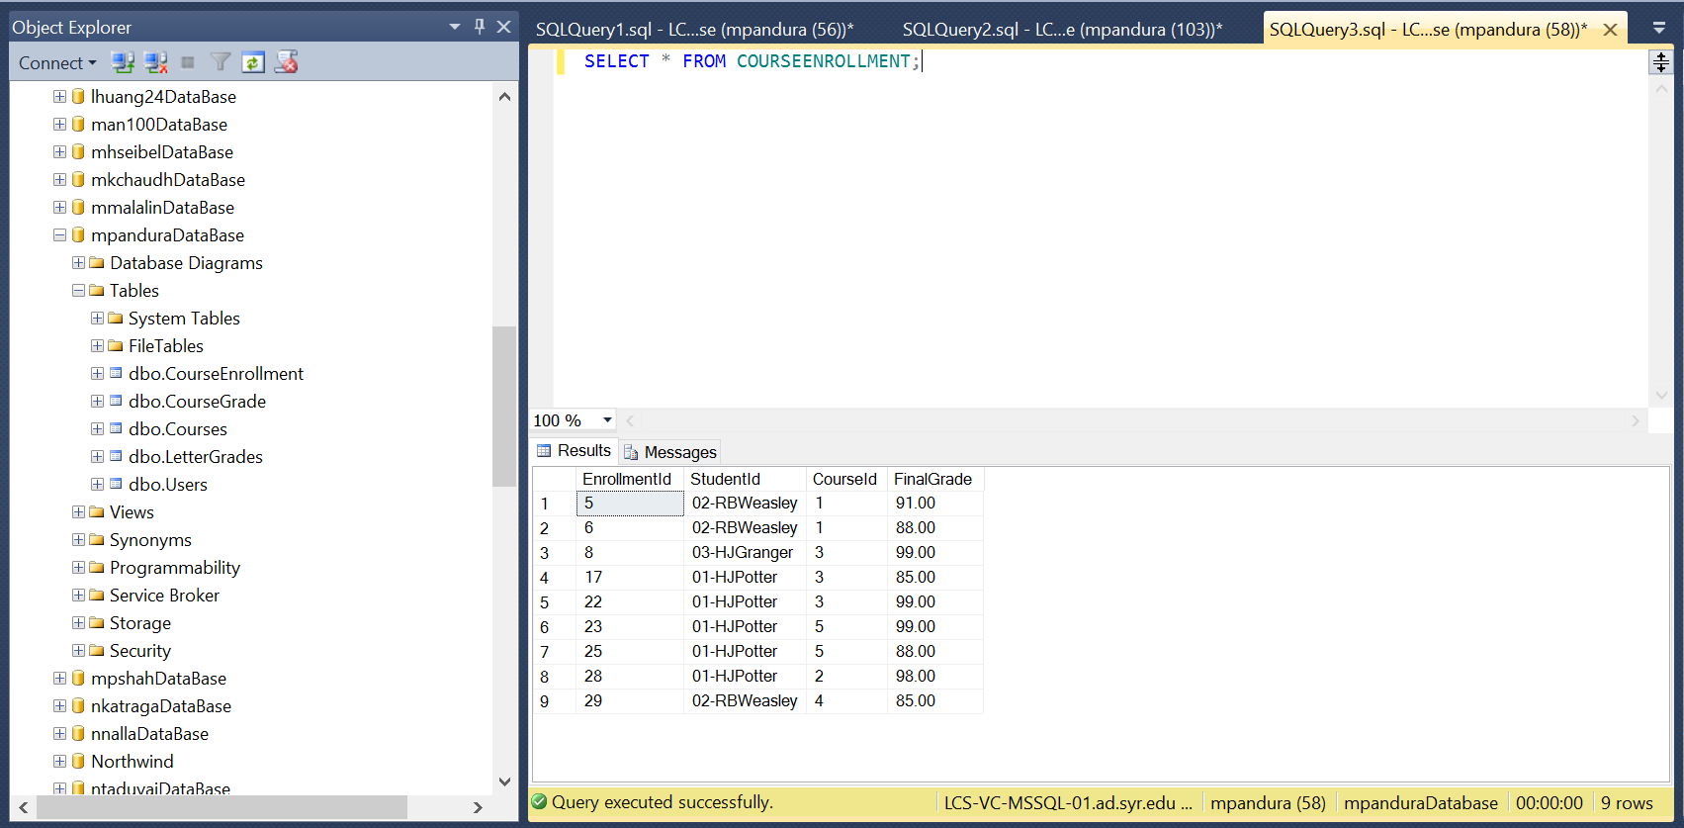



1. You can create 3 triggers, one per action. You can also create a single trigger that can do all 3 – this is more difficult to do – you need to think about how you can decide which action is happening based on the data you would see during the trigger execution. Doing it via a single trigger would give you 5% bonus.